**MESD LMS Documentation - Monitor and track users’ progress**

**Purpose**

Allow educators to monitor and track the progress of users. This includes the ability to view the progress of individual tasks or projects, as well as overall participation in various activities or blocks. The following capabilities were added to facilitate this:

* report/performance:view

**Usage**

1. Log in as an **Educator.**
2. Navigate to a course and click on **Reports**.
3. Click on a report

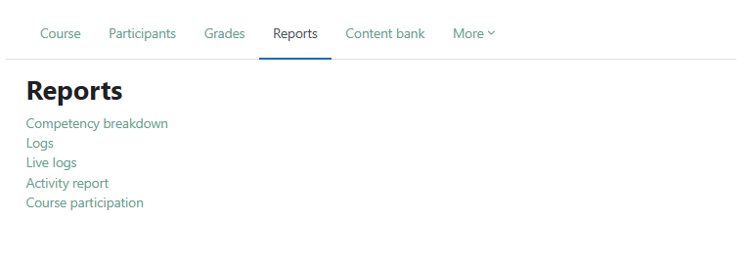

* **Competency breakdown report**

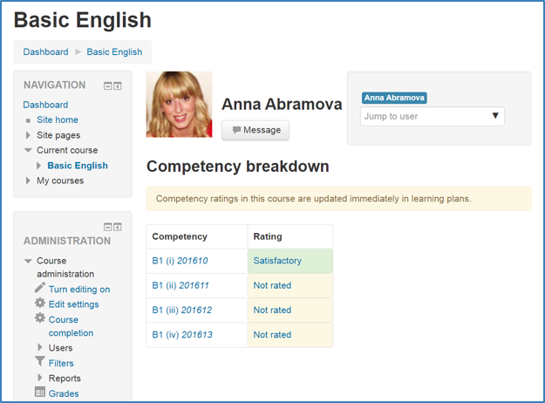These help track and evaluate a user's progress towards achieving specific competencies. These competencies represent the level of understanding or proficiency of a learner in certain subject-related skills.

Competencies are typically set up by an administrator, who can then create competency frameworks and add competencies to them. This is what a competency breakdown report should look like:

* **Logs**

Course logs provide a record of activities carried out by users within a specific course.

You can view the logs of an individual participant or multiple participants for selected activities as well as the actions they did.

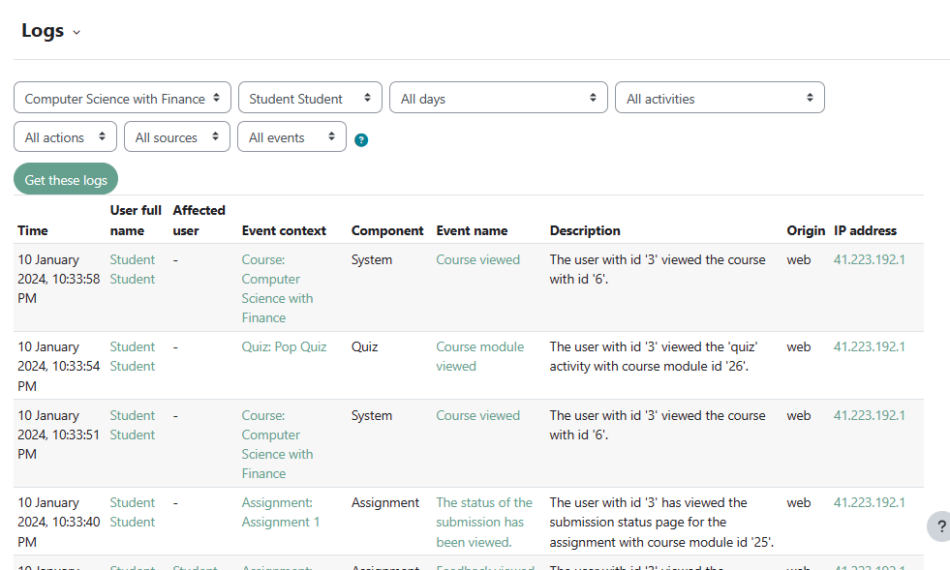

* **Live logs**

Live logs show recent activity of all participants in the course.

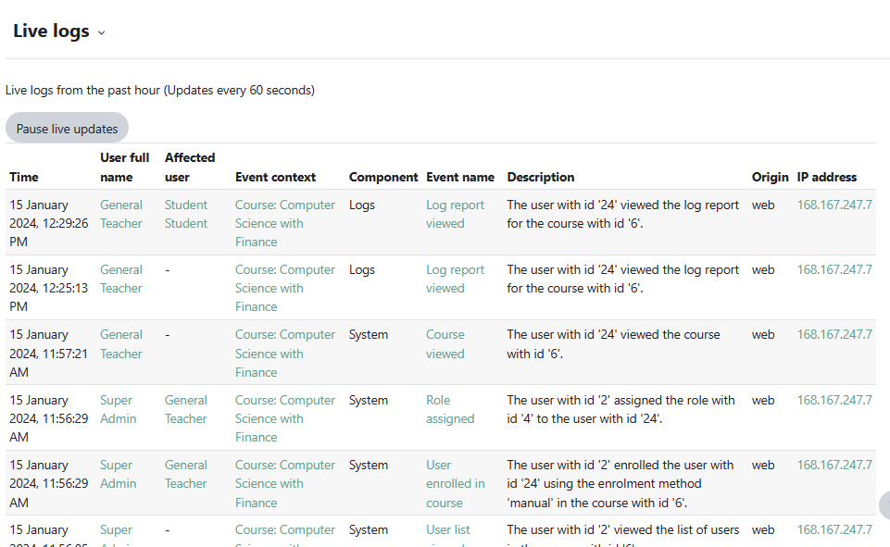

* **Activity report**

A course activity report shows the number of views a course activity or resource has.

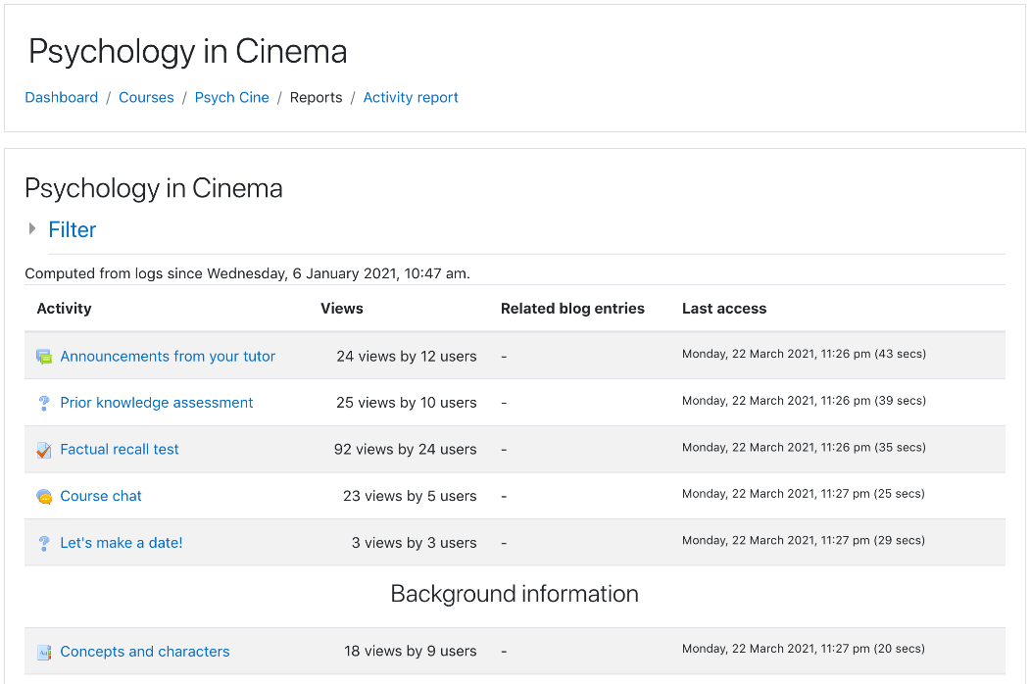

* **Course participation**

Course participation reports:

* Generate a list of who has participated in a given activity, and how many times.
* Can be filtered by role, group, and action (View or Post).
* Allow individuals or groups students (e.g. those who have not participated) to be easily messaged.

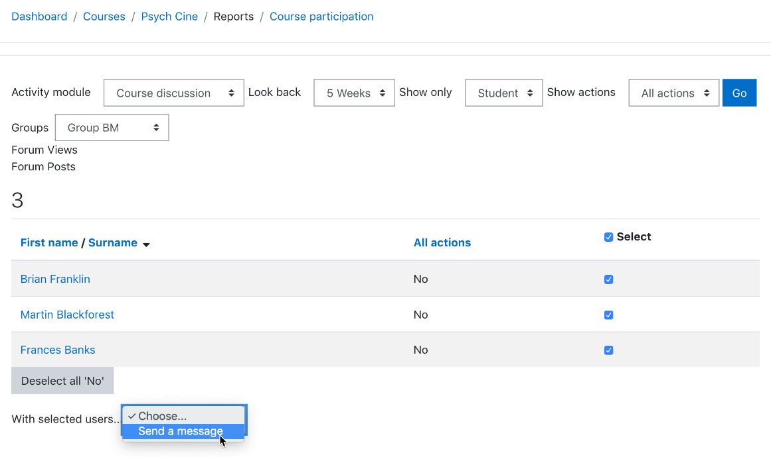

1. In addition to these reports Educators can view User reports to see a learner’s grade for each assessment. Go to Course administration > Grades and click on the **Grader report** drop down menu to go to **User report**.

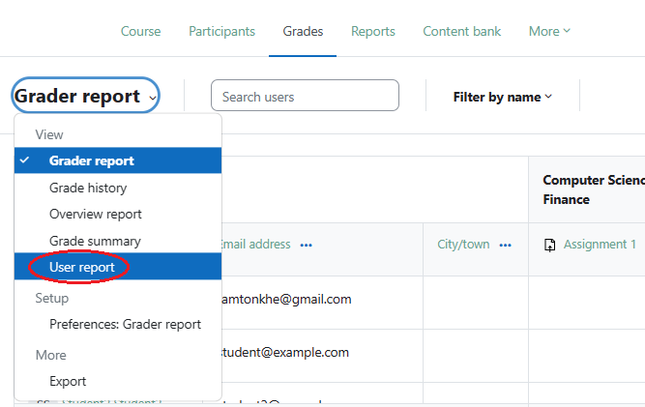

1. Search for a user and view their report.  
   